**Giving London a more South African Flavour**

April 20, 2021

**Introduction**

**Background**

Good food is one of things that just makes us feel comfortable. It can bring back cherished memories and leave us feeling satisfied. As a South African, I am quite used to popular food-chains coming to our shores. Mainly from USA, but also from Europe. They always come with a big reputation with lines regularly extending a long way out of the store, and people not being too concerned with having to wait a while to get their food or drinks.

Now, we are all familiar with huge fast-food chains such as McDonalds and KFC, and their popularity has not decreased as they have been in South Africa for many years now - KFC is in fact celebrating 50 years in South Africa in 2021.

London is the capital of England (and the United Kingdom), has a rich history, is filled with landmarks and tourist attractions (and good football teams), as well as being home to almost 9 million people.

**Problem**

Having been in the city of London in mid-2019 for a visit, I did not see too many South African shops or restaurants. Not that it bothered me too much as a tourist. But I can only imagine that a South African expatriate would want a bigger taste of home for those days when they may feel homesick.

I want to solve this problem and find the best possible spot to open a proudly South African restaurant in the heart of London.

**Interest**

Being so multicultural, it would make sense for London to cater to the needs and wants of their residents. Particularly when it comes to cuisine.

This South African restaurant would appeal to South African expatriates living in England, as well as local residents who may be curious to give it a try, and see if the hype is worth it.

South Africa is famous for food and snacks such as biltong, the Gatsby, vetkoek, potjiekos, bunny chow as well as boerewors, among others. The restaurant I intend to open will have all of these and more on its menu, and no doubt warm the heart – and stomach - of those familiar with them and convert those who are new to it.

**Data**

I will use the following sites to source data from which I can make an accurate decision:

<https://foursquare.com/explore?mode=url&ne=51.625264%2C0.140419&q=Food&sw=51.361492%2C-0.435677>

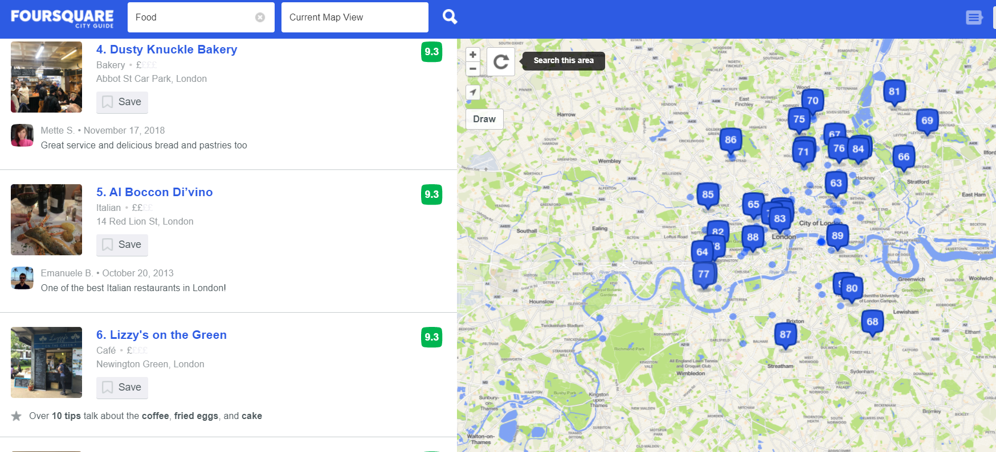

The above foursquare data shows a list of London restaurants and their location. I will scrape this data and convert it to a table for better analysis. From there, I can see if there is indeed a restaurant that is close to what I want to introduce.

I will also make use of this Wikipedia list (performing a similar operation to what I did above) to supplement the Foursquare data:

<https://en.wikipedia.org/wiki/List_of_restaurants_in_London>

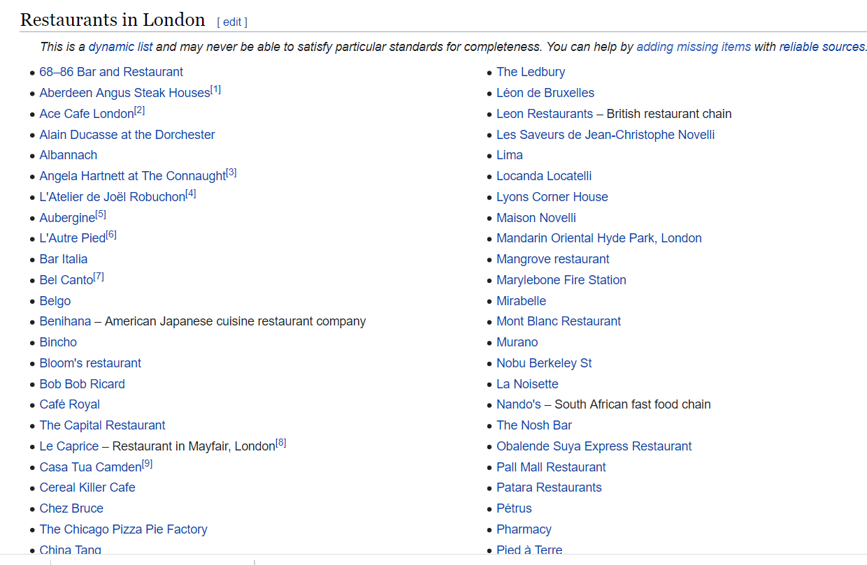

**Methodology**

Looking through the list of restaurants in the London, we see a clear lack of variety – especially when it comes to restaurants of South African taste.

I intend to remedy that and create a truly, unique experience for any local to taste something different, and for expats to have a taste of home.

Looking below through the list of London restaurants proves my aforementioned point:

|  |
| --- |
| * [68–86 Bar and Restaurant](https://en.wikipedia.org/wiki/68%E2%80%9386_Bar_and_Restaurant) |
| * [Aberdeen Angus Steak Houses](https://en.wikipedia.org/wiki/Aberdeen_Angus_Steak_Houses)[[1]](https://en.wikipedia.org/wiki/List_of_restaurants_in_London#cite_note-1) |
| * [Ace Cafe London](https://en.wikipedia.org/wiki/Ace_Cafe_London)[[2]](https://en.wikipedia.org/wiki/List_of_restaurants_in_London#cite_note-2) |
| * [Alain Ducasse at the Dorchester](https://en.wikipedia.org/wiki/Alain_Ducasse_at_the_Dorchester) |
| * [Albannach](https://en.wikipedia.org/wiki/Albannach_(restaurant)) |
| * [Angela Hartnett at The Connaught](https://en.wikipedia.org/wiki/Angela_Hartnett_at_The_Connaught)[[3]](https://en.wikipedia.org/wiki/List_of_restaurants_in_London#cite_note-3) |
| * [L'Atelier de Joël Robuchon](https://en.wikipedia.org/wiki/L%27Atelier_de_Jo%C3%ABl_Robuchon_(London))[[4]](https://en.wikipedia.org/wiki/List_of_restaurants_in_London#cite_note-4) |
| * [Aubergine](https://en.wikipedia.org/wiki/Aubergine_(London_restaurant))[[5]](https://en.wikipedia.org/wiki/List_of_restaurants_in_London#cite_note-5) |
| * [L'Autre Pied](https://en.wikipedia.org/wiki/L%27Autre_Pied)[[6]](https://en.wikipedia.org/wiki/List_of_restaurants_in_London#cite_note-6) |
| * [Bar Italia](https://en.wikipedia.org/wiki/Bar_Italia) |
| * [Bel Canto](https://en.wikipedia.org/wiki/Bel_Canto_(restaurant))[[7]](https://en.wikipedia.org/wiki/List_of_restaurants_in_London#cite_note-7) |
| * [Belgo](https://en.wikipedia.org/wiki/Belgo) |
| * [Benihana](https://en.wikipedia.org/wiki/Benihana) – American Japanese cuisine restaurant company |
| * [Bincho](https://en.wikipedia.org/wiki/Bincho) |
| * [Bloom's restaurant](https://en.wikipedia.org/wiki/Bloom%27s_restaurant) |
| * [Bob Bob Ricard](https://en.wikipedia.org/wiki/Bob_Bob_Ricard) |
| * [Café Royal](https://en.wikipedia.org/wiki/Caf%C3%A9_Royal) |
| * [The Capital Restaurant](https://en.wikipedia.org/wiki/The_Capital_Restaurant) |
| * [Le Caprice](https://en.wikipedia.org/wiki/Le_Caprice) – Restaurant in Mayfair, London[[8]](https://en.wikipedia.org/wiki/List_of_restaurants_in_London#cite_note-8) |
| * [Casa Tua Camden](https://en.wikipedia.org/wiki/Casa_Tua_Camden)[[9]](https://en.wikipedia.org/wiki/List_of_restaurants_in_London#cite_note-9) |
| * [Cereal Killer Cafe](https://en.wikipedia.org/wiki/Cereal_Killer_Cafe) |
| * [Chez Bruce](https://en.wikipedia.org/wiki/Chez_Bruce) |
| * [The Chicago Pizza Pie Factory](https://en.wikipedia.org/wiki/The_Chicago_Pizza_Pie_Factory) |
| * [China Tang](https://en.wikipedia.org/wiki/China_Tang) |
| * [Cipriani S.A.](https://en.wikipedia.org/wiki/Cipriani_S.A.) |
| * [Club Gascon](https://en.wikipedia.org/wiki/Club_Gascon) |
| * [Colony](https://en.wikipedia.org/wiki/Colony_(restaurant)) |
| * [Cranks](https://en.wikipedia.org/wiki/Cranks_(restaurant)) |
| * [The Cube](https://en.wikipedia.org/wiki/The_Cube_(restaurant)) |
| * [Dinner by Heston Blumenthal](https://en.wikipedia.org/wiki/Dinner_by_Heston_Blumenthal) |
| * [The Dorchester](https://en.wikipedia.org/wiki/The_Dorchester) – Hotel on Park Lane and Deanery Street, London |
| * [L'Entrecôte](https://en.wikipedia.org/wiki/L%27Entrec%C3%B4te) |
| * [L'Escargot](https://en.wikipedia.org/wiki/L%27Escargot_(restaurant)) |
| * [Food for Thought](https://en.wikipedia.org/wiki/Food_for_Thought_(restaurant)) |
| * [The French House, Soho](https://en.wikipedia.org/wiki/The_French_House,_Soho) |
| * [Fuzzy's Grub](https://en.wikipedia.org/wiki/Fuzzy%27s_Grub) |
| * [Gaby's Deli](https://en.wikipedia.org/wiki/Gaby%27s_Deli) – Jewish restaurant |
| * [Galvin at Windows](https://en.wikipedia.org/wiki/Galvin_at_Windows) – Michelin starred restaurant located on the top floor of the London Hilton on Park Lane restaurant |
| * [Le Gavroche](https://en.wikipedia.org/wiki/Le_Gavroche) – Restaurant in London, England |
| * [The Gay Hussar](https://en.wikipedia.org/wiki/The_Gay_Hussar) – Restaurant In London, England |
| * [Gilgamesh](https://en.wikipedia.org/wiki/Gilgamesh_(restaurant)) |
| * [Gioconda cafe](https://en.wikipedia.org/wiki/Gioconda_cafe) |
| * [Gordon Ramsay at Claridge's](https://en.wikipedia.org/wiki/Gordon_Ramsay_at_Claridge%27s) |
| * [Gordon Ramsay Plane Food](https://en.wikipedia.org/wiki/Gordon_Ramsay_Plane_Food) – Restaurant in Heathrow Airport Terminal 5 |
| * [Gourmet Burger Kitchen](https://en.wikipedia.org/wiki/Gourmet_Burger_Kitchen) |
| * [Grecian Coffee House](https://en.wikipedia.org/wiki/Grecian_Coffee_House) |
| * [Grodzinski Bakery](https://en.wikipedia.org/wiki/Grodzinski_Bakery) |
| * [Hakkasan](https://en.wikipedia.org/wiki/Hakkasan) |
| * [Hard Rock Cafe](https://en.wikipedia.org/wiki/Hard_Rock_Cafe) – Chain of restaurants |
| * [Harveys](https://en.wikipedia.org/wiki/Harveys_(restaurant)) |
| * [Hawksmoor](https://en.wikipedia.org/wiki/Hawksmoor_(restaurant)) |
| * [Hibiscus](https://en.wikipedia.org/wiki/Hibiscus_(restaurant)) |
| * [Hindoostanee Coffee House](https://en.wikipedia.org/wiki/Hindoostanee_Coffee_House) |
| * [InSpiral Lounge](https://en.wikipedia.org/wiki/InSpiral_Lounge) – London restaurant and events venue |
| * [Isow's](https://en.wikipedia.org/wiki/Isow%27s) |
| * [Itsu](https://en.wikipedia.org/wiki/Itsu) |
| * [The Ivy](https://en.wikipedia.org/wiki/The_Ivy) |
| * [The Jazz Café](https://en.wikipedia.org/wiki/The_Jazz_Caf%C3%A9) |
| * [Kai Mayfair](https://en.wikipedia.org/wiki/Kai_Mayfair) |
| * [Kuo Yuan](https://en.wikipedia.org/wiki/Kuo_Yuan) |
| * [Langan's Brasserie](https://en.wikipedia.org/wiki/Langan%27s_Brasserie) – restaurant in London, England |
| * [The Ledbury](https://en.wikipedia.org/wiki/The_Ledbury) |
| * [Léon de Bruxelles](https://en.wikipedia.org/wiki/L%C3%A9on_de_Bruxelles) |
| * [Leon Restaurants](https://en.wikipedia.org/wiki/Leon_Restaurants) – British restaurant chain |
| * [Les Saveurs de Jean-Christophe Novelli](https://en.wikipedia.org/wiki/Les_Saveurs_de_Jean-Christophe_Novelli) |
| * [Lima](https://en.wikipedia.org/wiki/Lima_(restaurant)) |
| * [Locanda Locatelli](https://en.wikipedia.org/wiki/Locanda_Locatelli) |
| * [Lyons Corner House](https://en.wikipedia.org/wiki/Lyons_Corner_House) |
| * [Maison Novelli](https://en.wikipedia.org/wiki/Maison_Novelli) |
| * [Mandarin Oriental Hyde Park, London](https://en.wikipedia.org/wiki/Mandarin_Oriental_Hyde_Park,_London) |
| * [Mangrove restaurant](https://en.wikipedia.org/wiki/Mangrove_restaurant) |
| * [Marylebone Fire Station](https://en.wikipedia.org/wiki/Marylebone_Fire_Station) |
| * [Mirabelle](https://en.wikipedia.org/wiki/Mirabelle_(London_restaurant)) |
| * [Mont Blanc Restaurant](https://en.wikipedia.org/wiki/Mont_Blanc_Restaurant) |
| * [Murano](https://en.wikipedia.org/wiki/Murano_(restaurant)) |
| * [Nobu Berkeley St](https://en.wikipedia.org/wiki/Nobu_Berkeley_St) |
| * [La Noisette](https://en.wikipedia.org/wiki/La_Noisette) |
| * [Nando's](https://en.wikipedia.org/wiki/Nando%27s) – South African fast food chain |
| * [The Nosh Bar](https://en.wikipedia.org/wiki/The_Nosh_Bar) |
| * [Obalende Suya Express Restaurant](https://en.wikipedia.org/wiki/Obalende_Suya_Express_Restaurant) |
| * [Pall Mall Restaurant](https://en.wikipedia.org/wiki/Pall_Mall_Restaurant) |
| * [Patara Restaurants](https://en.wikipedia.org/wiki/Patara_Restaurants) |
| * [Pétrus](https://en.wikipedia.org/wiki/P%C3%A9trus_(restaurant)) |
| * [Pharmacy](https://en.wikipedia.org/wiki/Pharmacy_(restaurant)) |
| * [Pied à Terre](https://en.wikipedia.org/wiki/Pied_%C3%A0_Terre_(restaurant)) |
| * [Pizza Express](https://en.wikipedia.org/wiki/Pizza_Express) |
| * [Pollen Street Social](https://en.wikipedia.org/wiki/Pollen_Street_Social) – Restaurant in London, England |
| * [Prospect of Whitby](https://en.wikipedia.org/wiki/Prospect_of_Whitby) – Public house in London, England |
| * [Quo Vadis](https://en.wikipedia.org/wiki/Quo_Vadis_(restaurant)) – Restaurant in Dean Street, Soho, London |
| * [Rasoi](https://en.wikipedia.org/wiki/Rasoi) |
| * [Regency Café](https://en.wikipedia.org/wiki/Regency_Caf%C3%A9) |
| * [Restaurant Gordon Ramsay](https://en.wikipedia.org/wiki/Restaurant_Gordon_Ramsay) – Restaurant in London, United Kingdom |
| * [Rhodes Twenty Four](https://en.wikipedia.org/wiki/Rhodes_Twenty_Four) |
| * [Rhodes W1](https://en.wikipedia.org/wiki/Rhodes_W1) |
| * [The River Café](https://en.wikipedia.org/wiki/The_River_Caf%C3%A9_(London)) – Restaurant in London, England |
| * [Roussillon](https://en.wikipedia.org/wiki/Roussillon_(restaurant)) |
| * [Rules](https://en.wikipedia.org/wiki/Rules_(restaurant)) |
| * [St. John](https://en.wikipedia.org/wiki/St._John_(restaurant)) |
| * [San Lorenzo](https://en.wikipedia.org/wiki/San_Lorenzo_(restaurant)) |
| * [Scandinavian Kitchen](https://en.wikipedia.org/wiki/Scandinavian_Kitchen) |
| * [Simpson's-in-the-Strand](https://en.wikipedia.org/wiki/Simpson%27s-in-the-Strand) |
| * [Sketch](https://en.wikipedia.org/wiki/Sketch_(restaurant)) |
| * [Sofra](https://en.wikipedia.org/wiki/Sofra_(restaurant)) |
| * [The Square](https://en.wikipedia.org/wiki/The_Square_(restaurant)) |
| * [La Tante Claire](https://en.wikipedia.org/wiki/La_Tante_Claire) |
| * [Titanic](https://en.wikipedia.org/wiki/Titanic_(restaurant)) |
| * [Tokyo Diner](https://en.wikipedia.org/wiki/Tokyo_Diner) |
| * [Tom Aikens](https://en.wikipedia.org/wiki/Tom_Aikens_(restaurant)) |
| * [Tom's Kitchen](https://en.wikipedia.org/wiki/Tom%27s_Kitchen) |
| * [Tower Restaurant](https://en.wikipedia.org/wiki/Tower_Restaurant) |
| * [Town of Ramsgate](https://en.wikipedia.org/wiki/Town_of_Ramsgate) – Pub in Wapping, London |
| * [La Trompette](https://en.wikipedia.org/wiki/La_Trompette_(restaurant)) |
| * [Union Street Café](https://en.wikipedia.org/wiki/Union_Street_Caf%C3%A9) |
| * [Veeraswamy](https://en.wikipedia.org/wiki/Veeraswamy) – Indian restaurant in London |
| * [Wagamama](https://en.wikipedia.org/wiki/Wagamama) |
| * [The Wolseley](https://en.wikipedia.org/wiki/The_Wolseley) |
| * [Wong Kei](https://en.wikipedia.org/wiki/Wong_Kei) |
| * [Yauatcha](https://en.wikipedia.org/wiki/Yauatcha) |
| * [YO! Sushi](https://en.wikipedia.org/wiki/YO!_Sushi) |
| * [Zafferano](https://en.wikipedia.org/wiki/Zafferano) |
| * [Zuma](https://en.wikipedia.org/wiki/Zuma_(restaurant)) |

**Conclusion**

There is always a gap in the market for a product or service of top quality.

As a biased South African, I can say that our food will be welcomed abroad by expatriates and knowing our communal and inclusive nature, is very likely to be adopted and liked by those who are new to it.

I look at the above results and see that opening a proudly South African restaurant in the heart of London, close enough to

Lekker eet!